**Create an EBS Volume**

* Selecting the **volume** tab in the EC2 dashboard

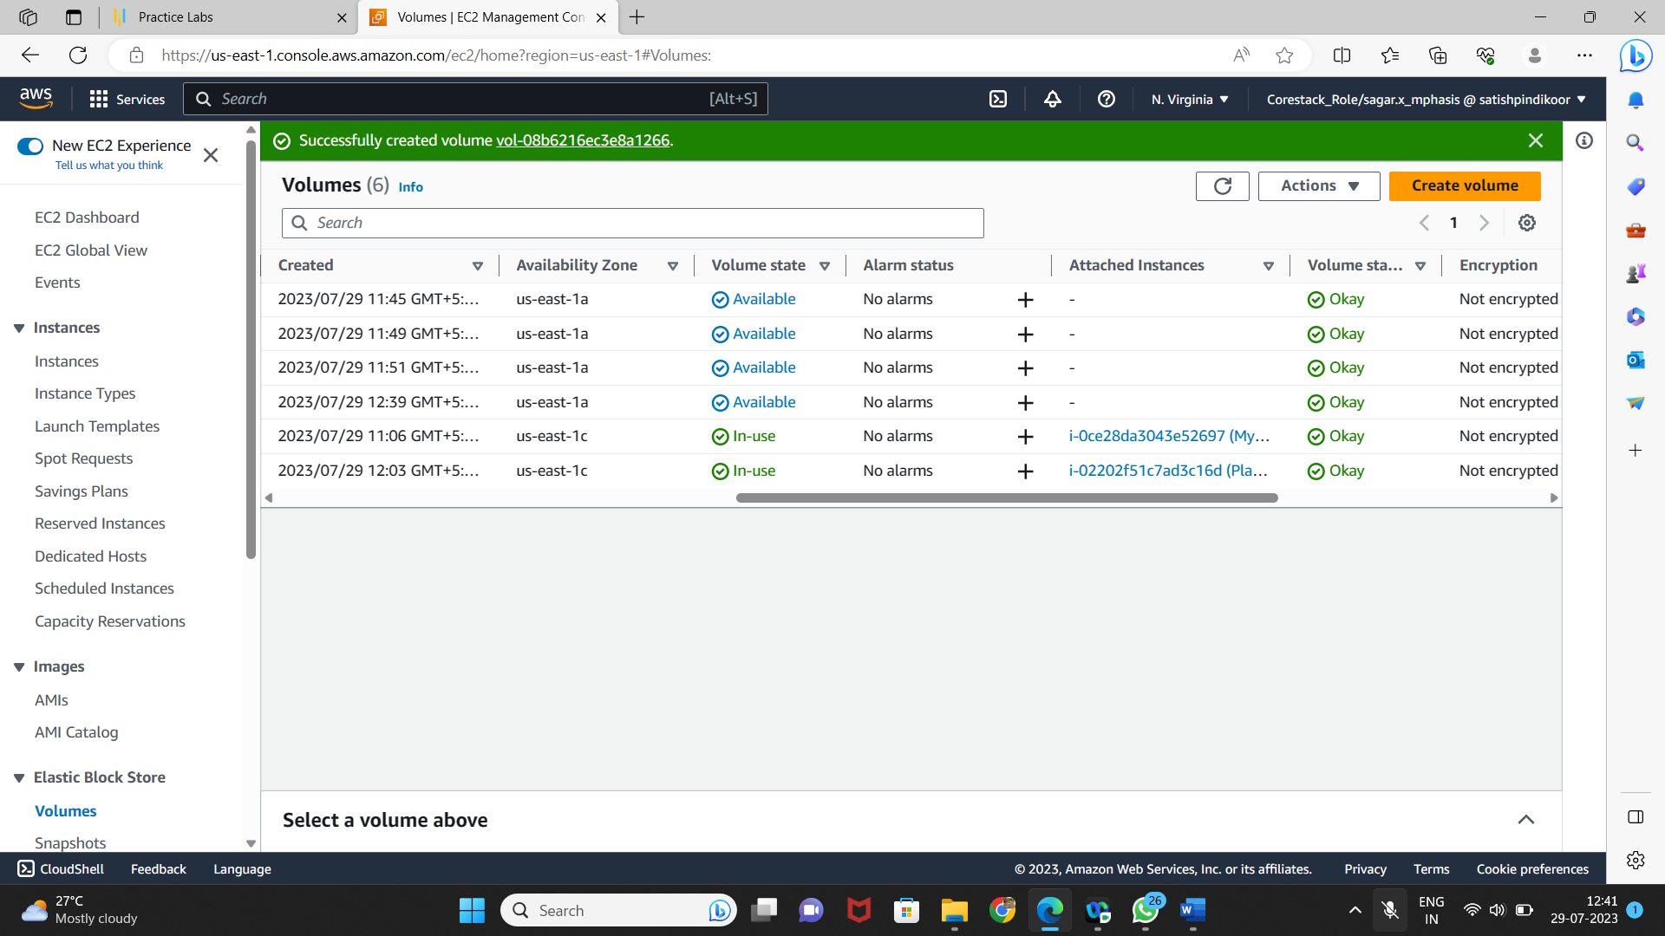

* Creating a new volume by clicking on **Create**

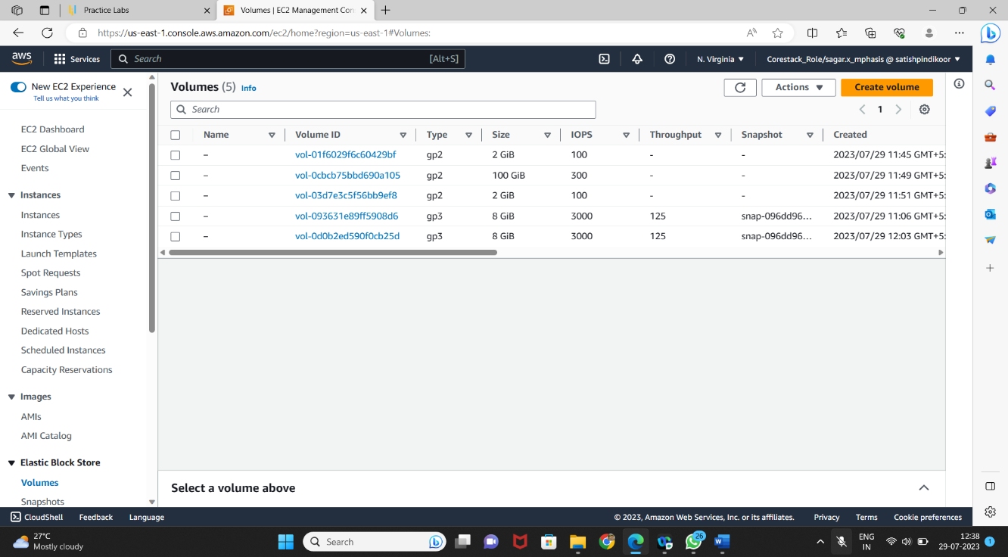

* Selecting the volume type according to the project requirement
* Creating a new volume by specifying the size and defining the zone

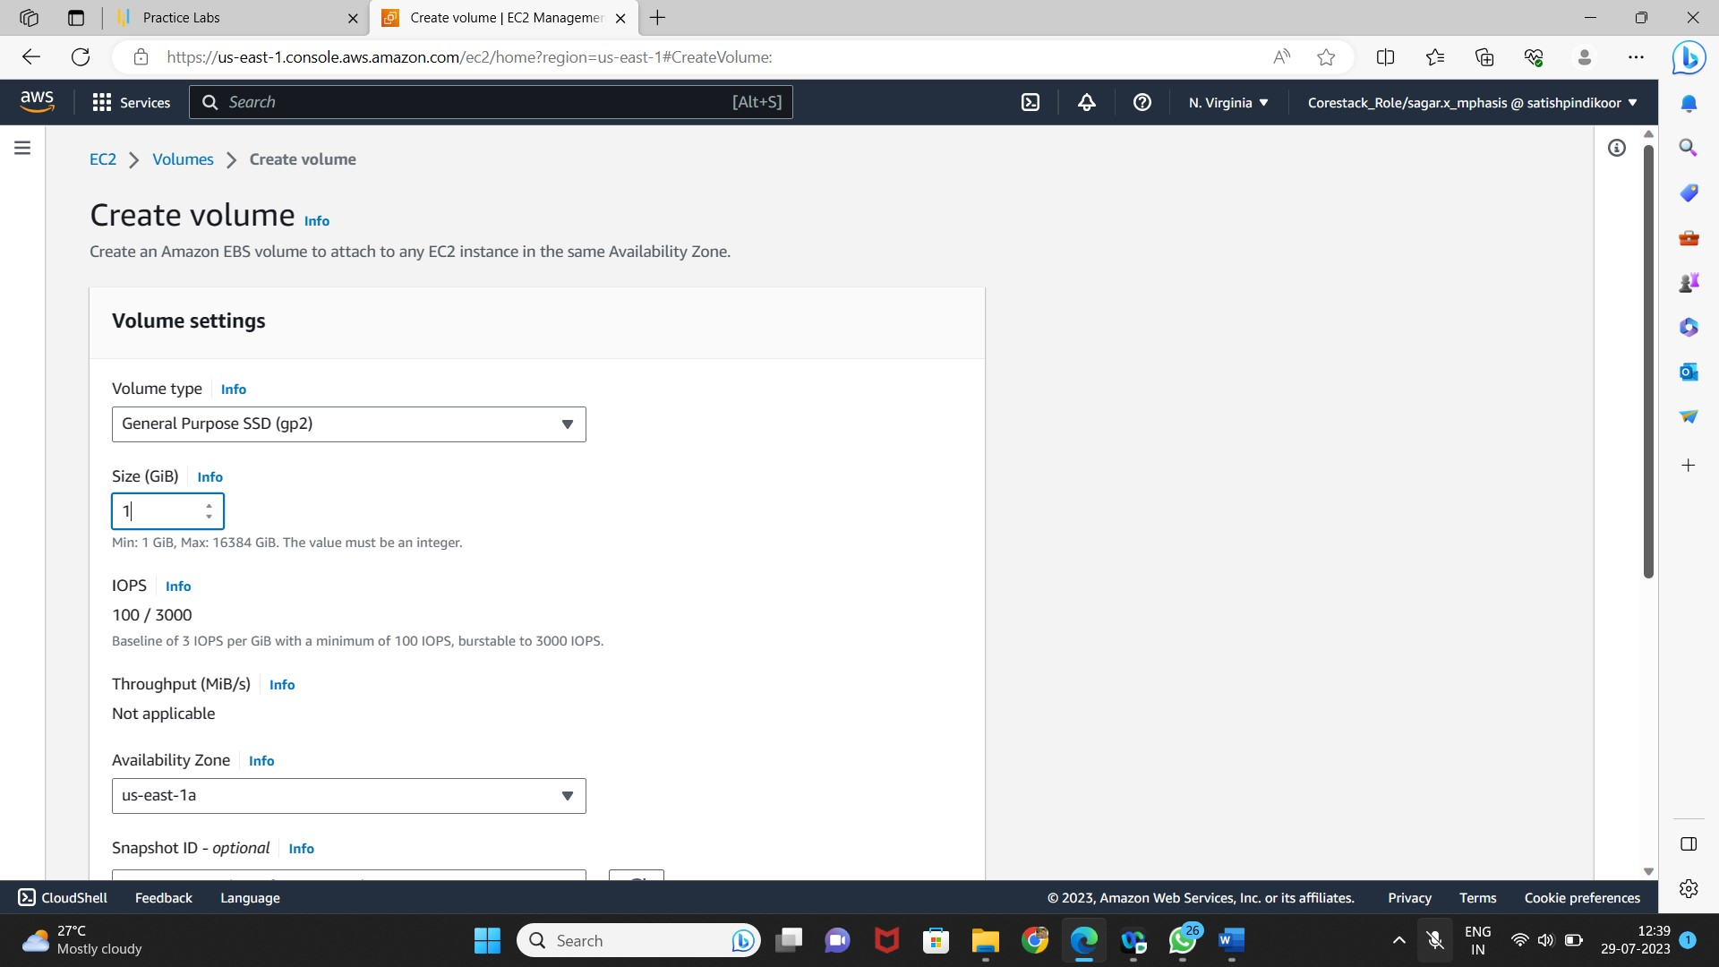

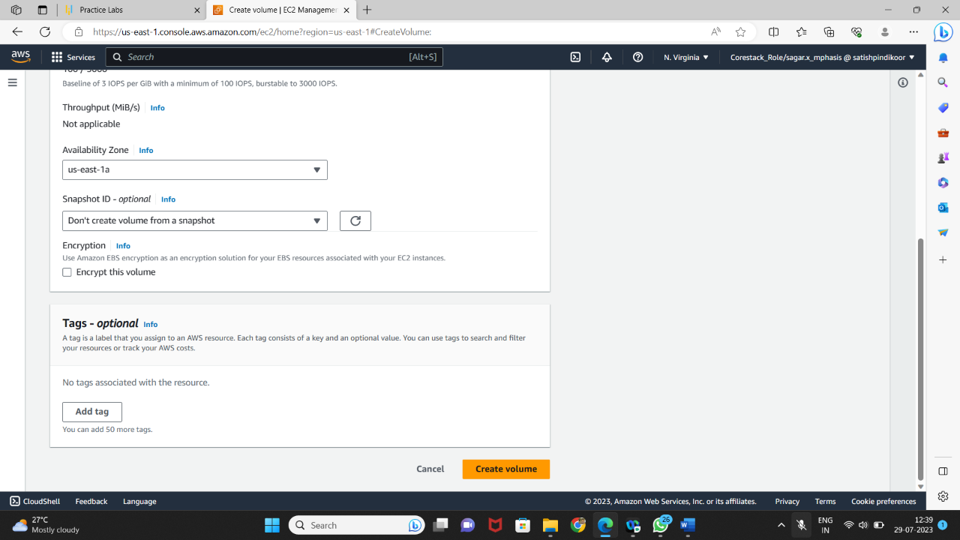

* Verifying the new volume created on the volume console and its availability

